**ASSIGNMENT 3**

NAME : RAJARSHI CHOWDHURY

UNIVERSITY ROLL : 11500120095

**Problem Statement:**

1. Write a Java Program to illustrate Scanner, BufferReader, BufferedWriter and System class for input and output from terminal and files. (You may write multiple programs as per your wish)
2. **Using Scanner :**

**CODE :**

import java.util.*;

class ScannerDemo{

public static void main(String[] args){

Scanner myObj = new Scanner(System.in);

System.out.print("Enter Name : ");

String name = myObj.nextLine();

System.out.print("Enter Roll number : ");

Long roll = myObj.nextLong();

System.out.println("Name : " + name);

System.out.println("Roll number : " + roll);

}

}

**OUTPUT :**

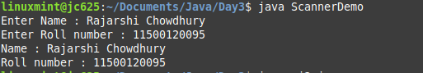

1. **Using BufferedReader:**

**CODE :**

import java.io.*;

class BufferDemo{

public static void main(String[] args ) throws Exception{

FileReader file = new FileReader("romeo.txt");

BufferedReader buffer = new BufferedReader(file);

while (buffer.ready()) {

System.out.println(buffer.readLine());

}

}

}

**FILE :**

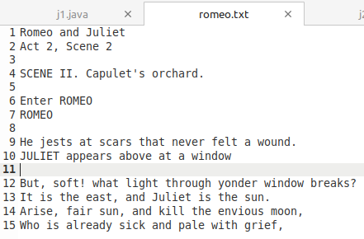

**OUTPUT :**

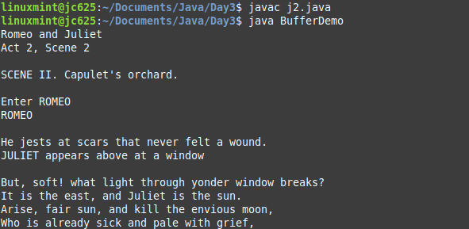

1. **using BufferedWriter:**

**CODE :**

import java.io.*;

class WriterDemo{

public static void main(String[] args ) throws Exception{

String data = "I have become comfortably numb ";

FileWriter file = new FileWriter("daf.txt");

BufferedWriter buffer = new BufferedWriter(file);

buffer.write(data);

buffer.close();

}

}

**OUTPUT :**



**IN FILE :**

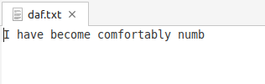

1. Write a Java Program to implement simple calculator using command line arguments.

**CODE :**

import java.util.*;

class calculator {

public static void main(String args[]){

int val1 = Integer.parseInt(args[0]);

int val2 = Integer.parseInt(args[2]);

int result;

switch(args[1]){

case "+":

result= val1 + val2;

System.out.println("Sum : "+result);

break;

case "-":

result= val1 - val2;

System.out.println("Difference : "+result);

break;

case "x":

result = val1 * val2;

System.out.println("Product : "+result);

break;

case "/":

result =val1 / val2;

System.out.println("Quotient : "+result);

break;

default:

System.out.println("Try again");

}}}

**OUTPUT :**

